ZOOM Children’s Activity August 1st
Hello boys and girls,
I hope that you are well and enjoying the summer break.
Today’s Bible story is a bit difficult to understand.
Let me ask you a question? Do you ever feel hungry?
I certainly do!
Another question: What is your favourite food?
I like a nice Sunday roast dinner and sticky toffee pudding...YUMMY.
BUT after you have eaten what happens?
A little later you feel hungry all over again!!
Well today, Jesus says that he can be ‘the bread of life’ because he doesn’t just fill our tummies with food, he fills our hearts with love…so much love that we can share that love with our families and our friends and even our neighbours.
There is nothing better than giving someone a GREAT BIG HUG and telling them that you love them.

This next week, wouldn’t it be wonderful if you could share your love with lots of people and tell them that it was Jesus who gave you that love to share.
This week there are two colouring sheets and a RECIPE!!
Enjoy! Sue x

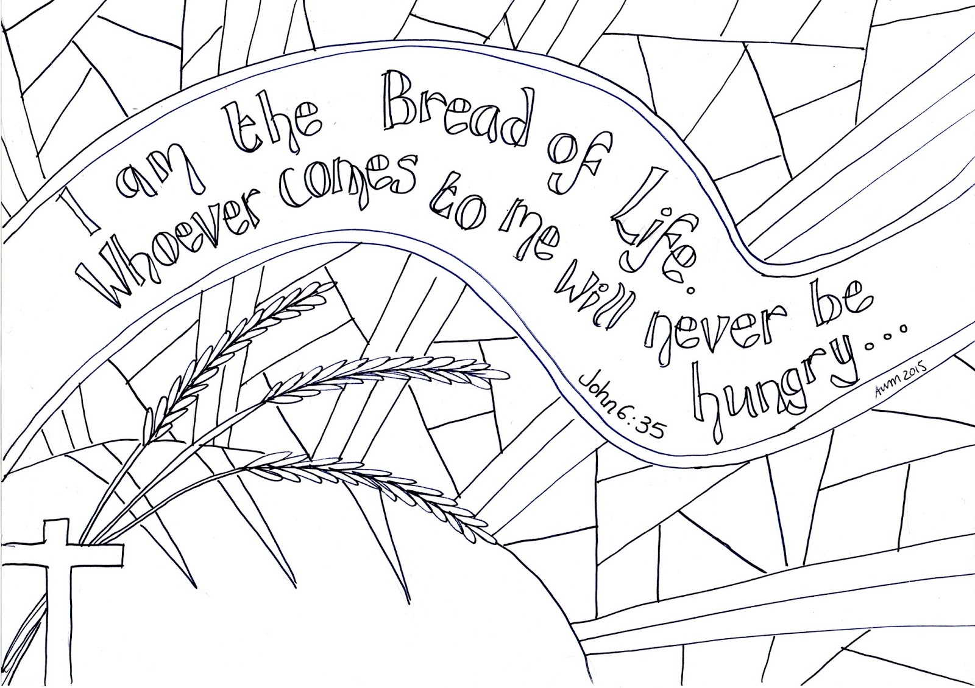

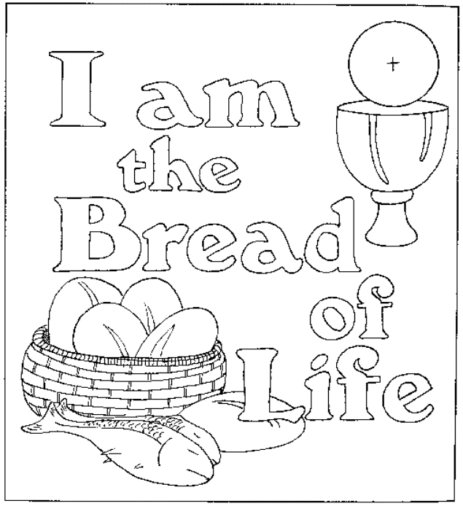

Would YOU like to make some PITTA BREAD to share with your family and friends when you share your love with them?
This recipe is so easy.
INGREDIENTS
300g plain flour
Half teasponn of salt
50g of butter
185mls of milk
Half tablespoon of oil [for cooking]
INSTRUCTIONS
- Melt the butter and add to the milk
- Put the flour and salt in a bowl and add the milk and butter.
- Mix it all together and then when you have a ball of dough put it on a floured surface and gently knead for 2 minutes.
- Cover the dough with cling film and leave for 30 minutes.
- Divide into 4/5 pieces and shape each piece into a thin round
- Heat a frying pan on a medium heat and put in a drop of oil.
- Put one of the rounds into the pan and cook for a minute or two, it should start to bubble up and turn golden
- then flip it over and cook the other side.
- Put on a plate and cover with a tea towel to keep it warm.
10.Cook the other pieces then you wil be ready to share your warm pitta bread with your family and friends.
THEY ARE DELICIOUS spread with a little bit of butter.
ENJOY!
