ZOOM Children’s Activity, October 23rd 2021
Hello boys and girls, it is good to be with you on BIBLE SUNDAY. This is a special day when we think about the Bible and what a very special, very important book it is.
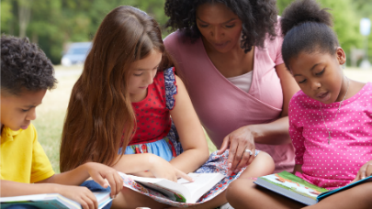
The BIBLE is ONE BIG BOOK divided into two parts. Each part is made up of many different books, There are 66 books altogether and each was written by a different person or group of people.
In the OLD TESTAMENT, we can read about the time before Jesus was born; the NEW TESTAMENT we learn all about Jesus and his friends.
In the Old Testament, I love reading about Noah and how God asked him to build a big boat called an ARK and fill it with pairs of lots of different animals. It must have been so noisy in there!
In the New Testament, I love reading stories of how Jesus helped so many people and he tells us how much he loves US and wants us to follow him by making good choices every day. Jesus also gave us a special prayer to say if we can’t think of what to say to him.
In the Bible there are stories about boys and girls just like you. There is a story about a GIANT and a boy called DAVID, there is a story about a GREAT BIG FISH. There are so many exciting things: you just need to open your Bible and you will find so much more.
There are lots of Activity sheets for you this week because next week I am on holiday! I do hope that you really enjoy them.
Sue
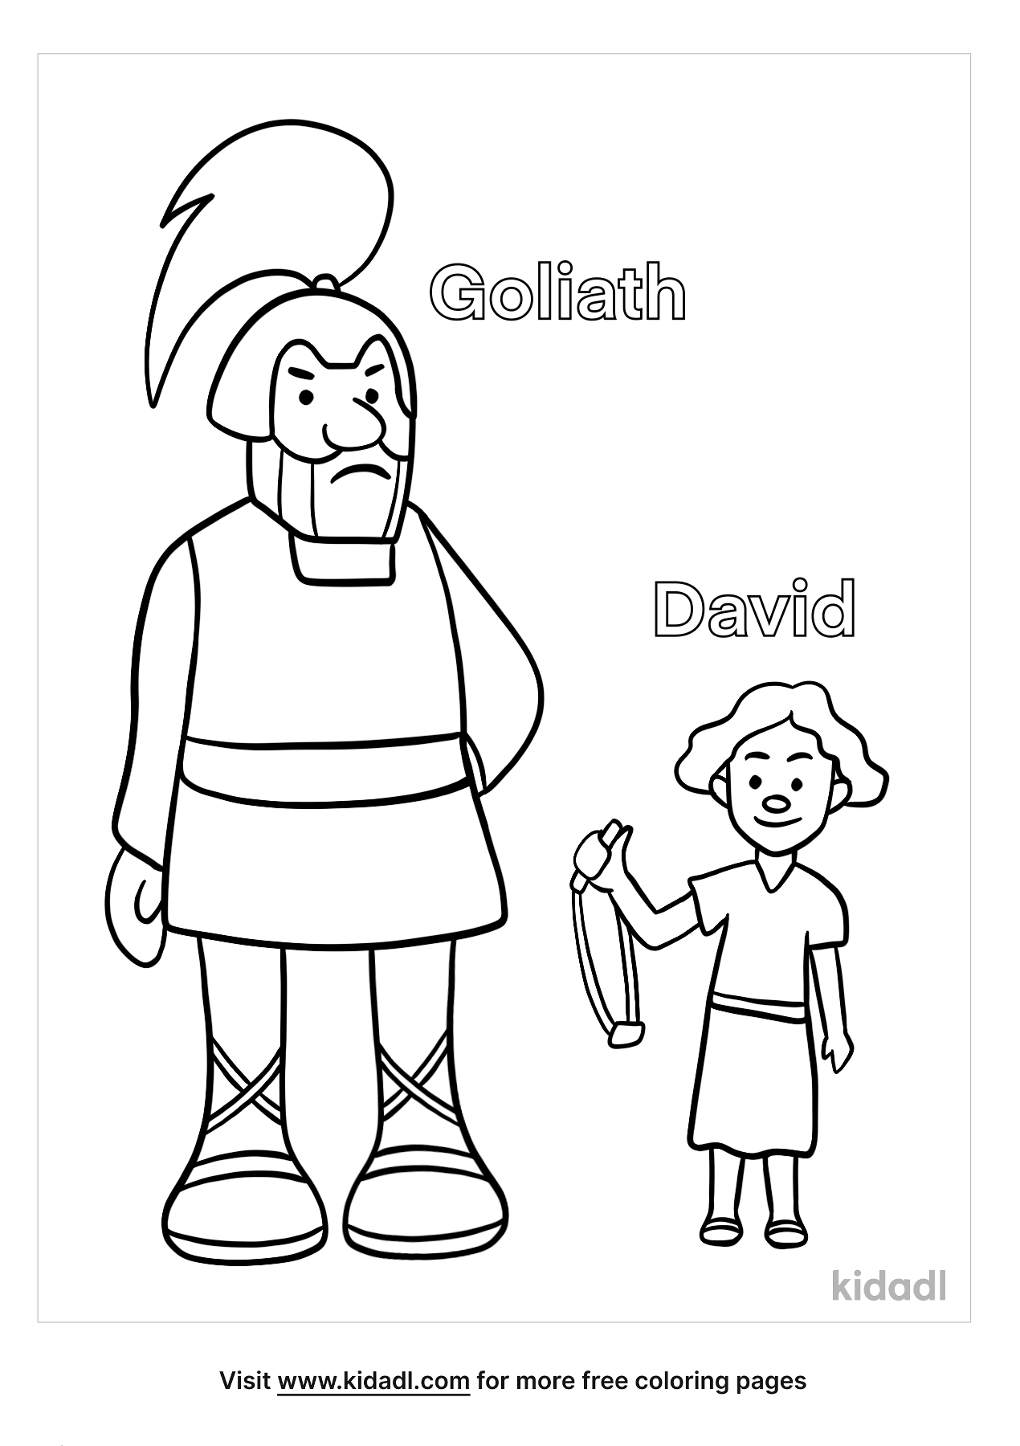
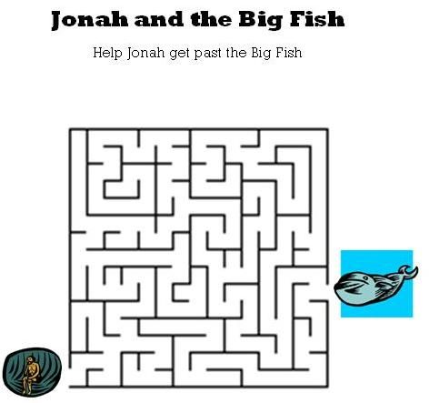

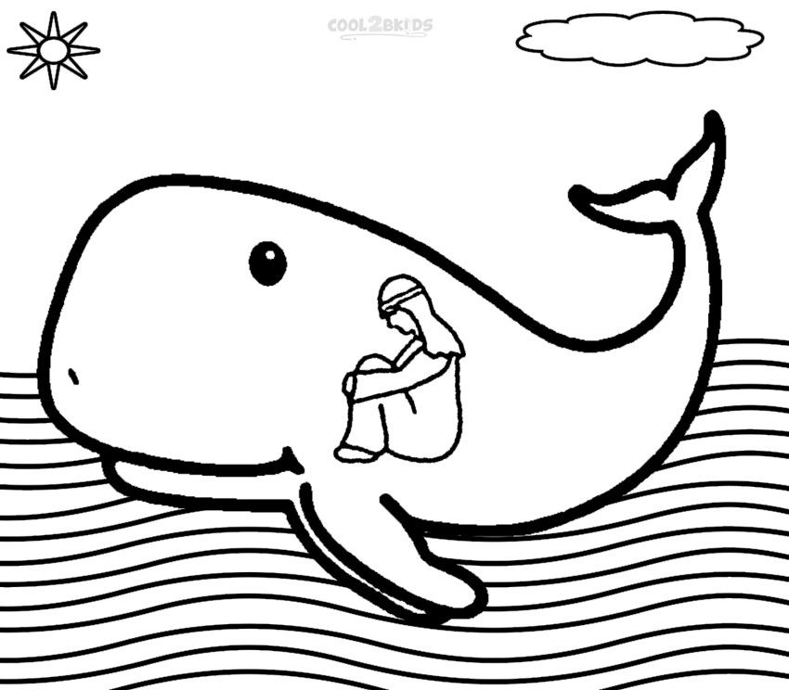
Jonah inside the big whale’s tummy…oh no!
Then the whale spat him out onto the land!
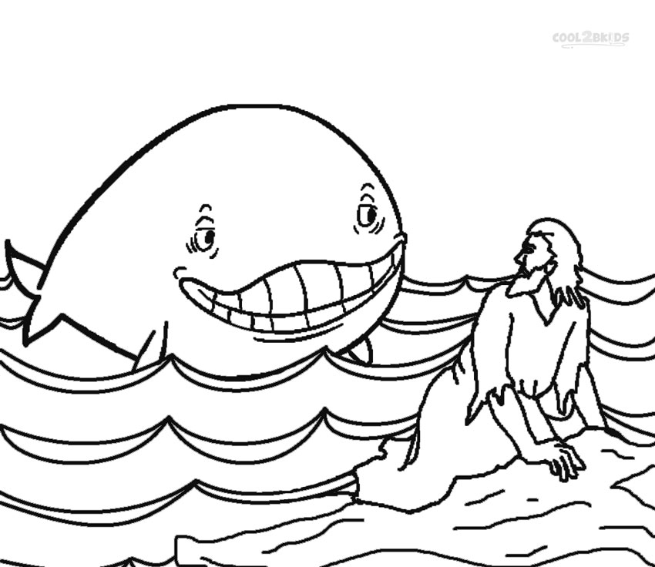
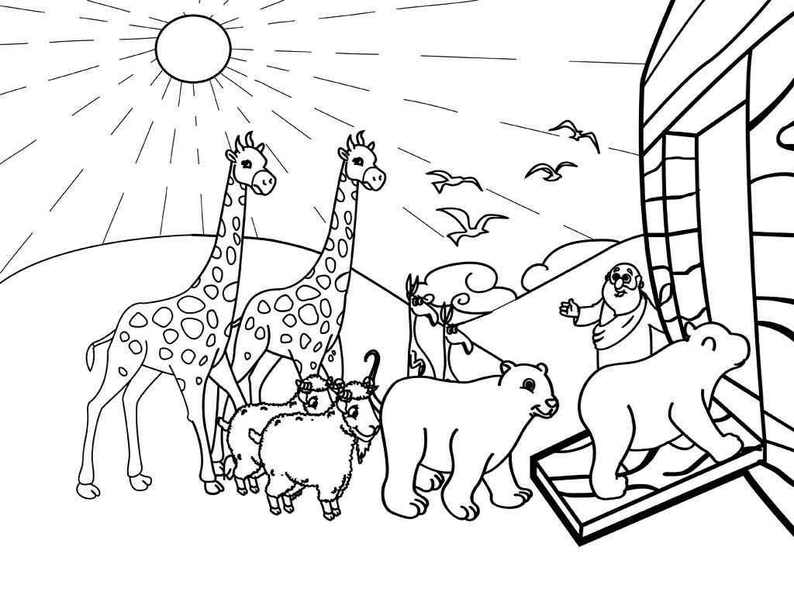

Here is Noah outside of the great big boat that he built. He is welcoming all the animals on board.
Can you draw some more animals creeping, crawling, slithering into the Ark?
Perhaps 2 cats, 2 spiders, 2 snakes, 2 snails?
I would love to see your pictures posted on St Luke or Cronton WhatsApp
