ZOOM Children’s Activity May 15th
I hope that you have had a good week and have remembered to say Thank you to all those people who have helped you!

This week’s reading is really SUPER IMPORTANT and something that we must NEVER forget.
Jesus tells his disciples:
‘You must love one another as I have loved you.’
They must do their best to be kind and caring, loving and sharing and think of others and not themselves.
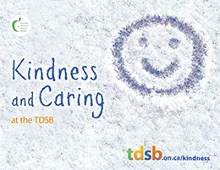
I expect, in fact I KNOW…that YOU will have done something to help someone else this week.
Can you share with a grown up what that is?
NOW…YOU ask the grown up what
THEY have done to help someone this week
We say that is being CHRIST LIKE because Jesus was always helping other people, young and old, rich and poor, happy or sad, those with lots of friends and those with none. We do our very best to be just like him.
Have fun with this week’s activities….Sue x

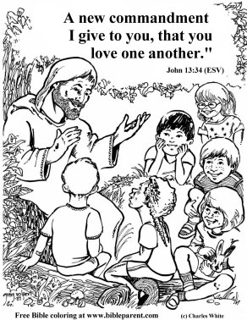
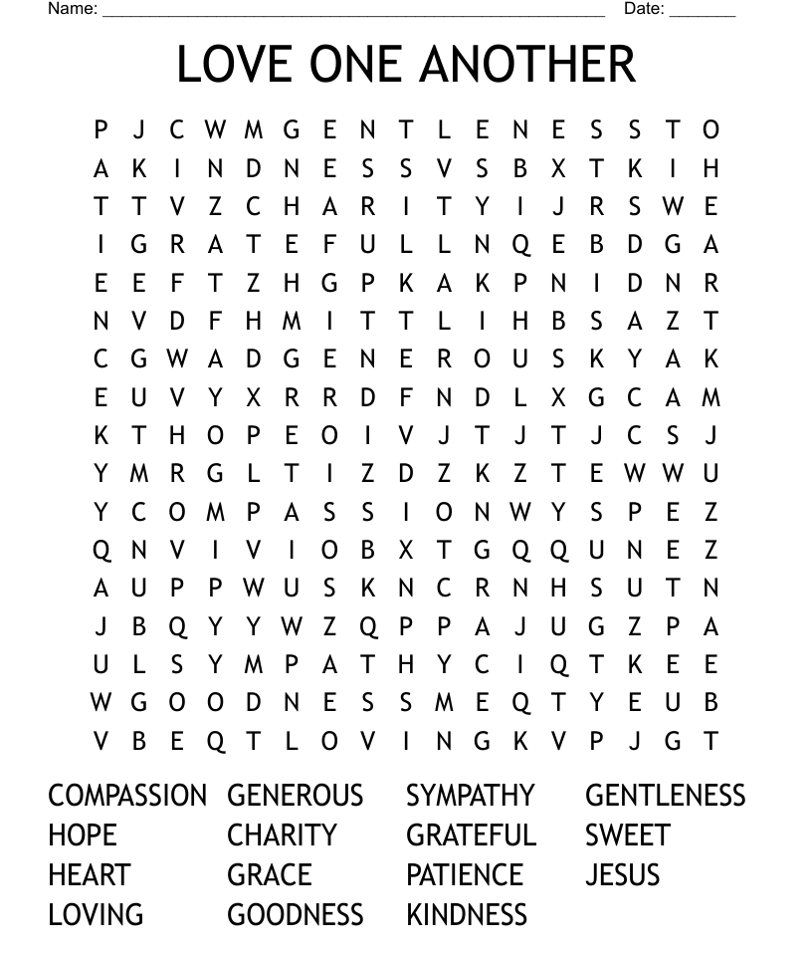

Cut out the heart shape.
Use your finger prints to fill the heart to show how much YOU love other people.

