ZOOM Children’s Activity for June 26th
Hello boys and girls, I hope that you are well and have had a good week at Nursery and school.
This week our Bible story tells us that it isn’t always easy to follow Jesus. Sometimes we have to give things up. It is a bit like when you want to play sports or do gymnastics or learn to dance, you can’t do two things at the same time and you have to give something up.
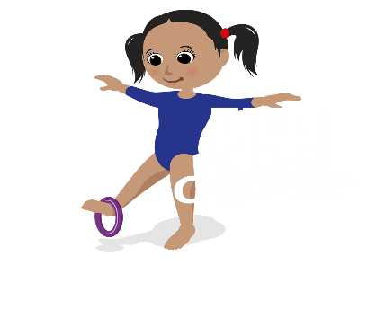 | Have you ever tried to stand on one leg and twirl a hoop on your foot at the same time?  Try, it isn’t easy!
But Jesus promises that he will always stay close. He will help us to make good choices and follow his ways, teaching us to be: kind and caring, loving and sharing, so that’s really good isn’t it.
Can you think of something really special that you could do this week to show others that you are a follower of Jesus? | 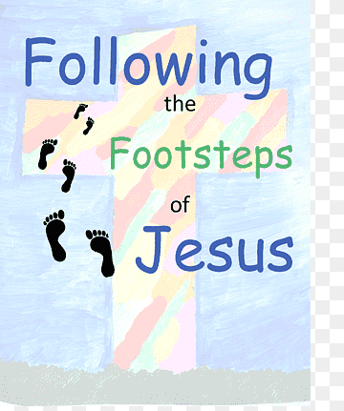

I hope that you enjoy this week’s activities. Sue x

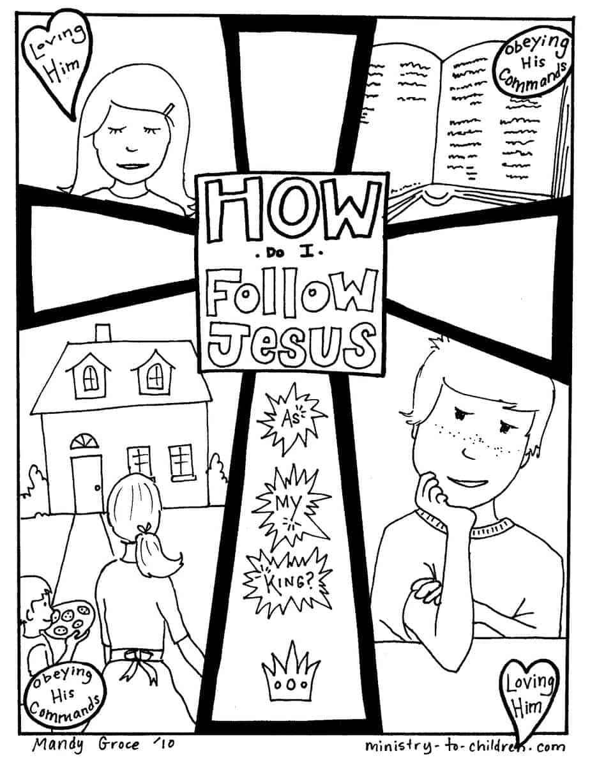
These are some of the things that Jesus tells the people in today’s story
