ZOOM Children’s Craft Sunday June 20th Father’s Day
Hi boys and girls,
I hope that you have had a lovely week and enjoyed the sunshine.
This week is when we think about Dad’s and others who are like a dad to us. so people who love us and take care of us, people who look out for us.
It’s the special day when we take time to say a great big THANK YOU to them and to God for them being in our lives.
I thought it might be nice for us to make an ‘I love you to the moon and back’ picture rather than a card; you can choose who to give it to, your daddy, your grandad, a special uncle….YOU can decide. If you need some of these materials please ring or text me and I’ll deliver them to you..…07962012916
We are going to build our picture step by step.
1, Take the piece of dark card for the sky.
2. Cut out the rocket shape and stick it onto the card.
3. Cut out two ‘fins’ and stick them onto the side of the rocket.
4. Using the piece of white pape,r draw round your hand ond colour in the
shapes using bright colours. Cut out these hand shapes… they are going
to be the flames. Stick one hand over the other on the back of the rocket.
5. Cut out two circles, these are going to be the windows. Stick them
onto the rocket.
6. Draw yourself in one ‘window’ and the person to whom you are going to
give the picture in the other.
7. Next, cut out a cricle for the moon and colour it yellow.
8. You can write this special meesage before you stick the shape onto your
picture. I love you to the moon and back.
9. Now scatter stars in the sky.
10. Well done! Your ZOOM ROCKET is all finished….clever you!

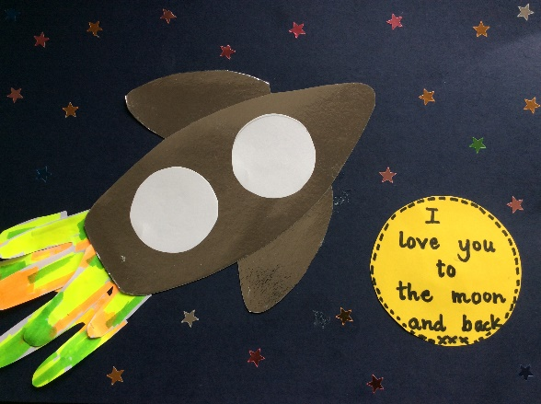 | I hope that you enjoy making your picture and I loook forward to you showing them at our special ZOOM Father’s Day service at 10.30am on Sunday. Sue xx
