ZOOM Children’s Activity for July 17th

Our Bible story today is about two sisters.
Their names were Mary and Martha.
They were friends of Jesus and he often went to their home to visit them.
The sisters were very different.
One liked to be still and quiet, the other liked to be busy and on the go all the time.
We all need busy people in our lives…
I expect that your Mum or your Dad, or someone who looks after you, is always busy with cooking and cleaning and helping you.
But sometimes we need to be still and quiet…. and take time to think about things…
sometimes we need quiet time
to think about Jesus and all he does for us!

Two of the activities are a bit tricky this week.

I hope that you have fun with them… Sue x

This activity is a tricky one…you might need a grown up to help you to write the letter of each drawing then read the words. You can colour everything in then.
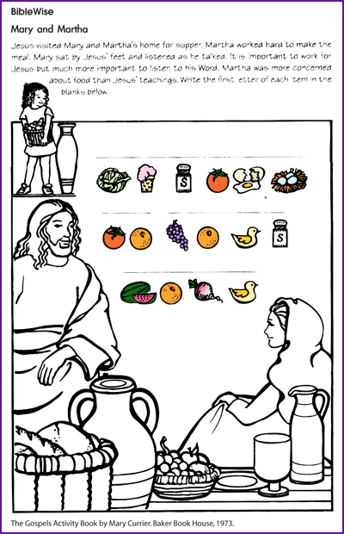
You will need a lollipop stick, scissors and selloptape.
Carefully cut round the figures, stick them onto the sticks
to make your own Jesus, Mary and Martha puppets.
Can you tell the story in your own words using the puppets?
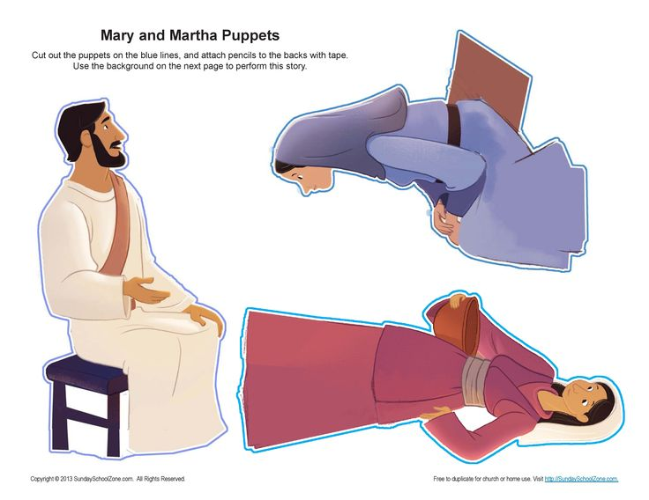

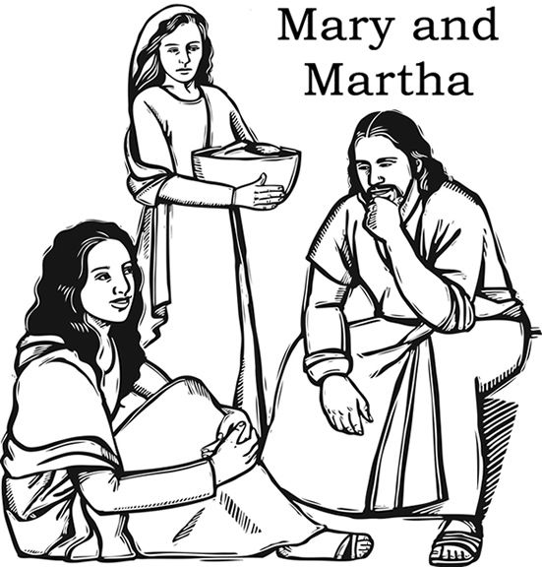

What do you think Jesus is saying?

