ZOOM Children’s Activity May 8th
…..I hope that you and everyone in your family is well.
One of our readings for today could have been PSALM 23.
Psalm 23 is a very well known reading from the Bible.
It was written by a man called David and he was a shepherd. ALL shepherds have a very important job to do. They have to look after all the sheep and keep them safe and well. Sometimes if sheep wander off they need to be gently brought back into the fold with all the others. Sometimes they get hurt and the shepherd needs to make them better.
Who looks after YOU and keeps YOU safe and well?
GOD PROMISES ALWAYS TO LOOK AFTER US TOO!
Do you every stop and remember to say THANK YOU to the people who help you?
That is so important.
Jesus taught us to be kind and caring, loving and sharing and he would want us to remember to thank the people who help us.
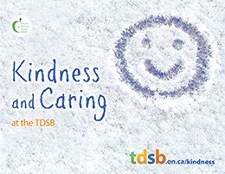
- Today one of the activities is to make ‘Thank you’ cards to give to people who help you.
- Another is to help the shepherd find a lost sheep.
- The last is a colouring sheet with a shepherd looking after his sheep…just like Jesus looks after us!
I hope that you enjoy the activities…have a good week and remember to say THANK YOU!! Sue x
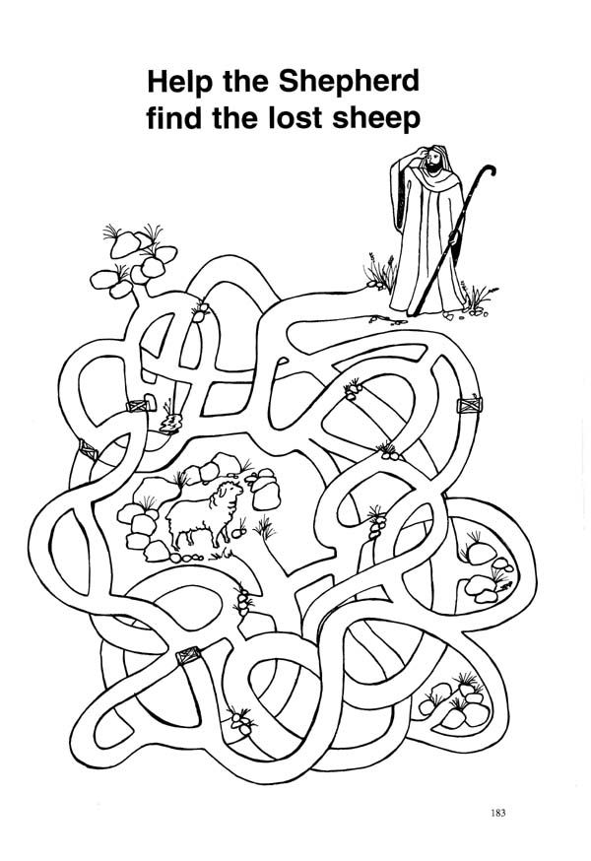
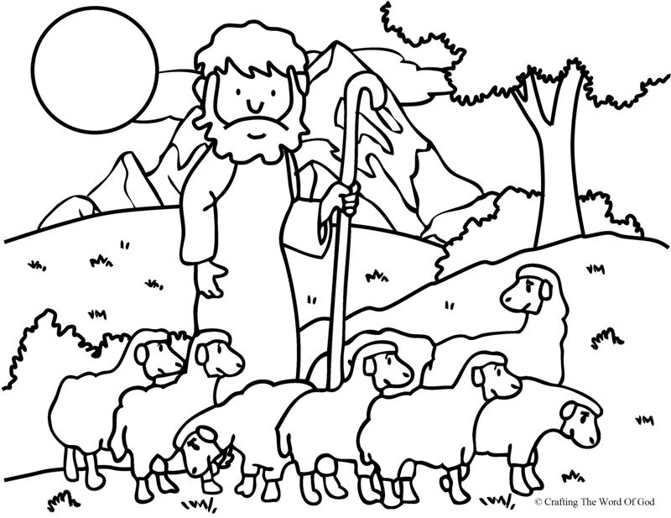

Cut along the dotted lines to make 2 Thank you cards. Colour and fold
……………………………………………………………………
……………………………………………………………

